PROG2002 – Web Development II
Assignment 3: A Complete Dynamic Website (Client-side & Admin-side)
Student ID: 24832407
Last Name: Liu
First Name: Boyu
Team members: Boyu Liu (24832407), Xiang Hu
Title of the project: Hearts United – A Complete Dynamic Charity Events Website

Introduction / Motivation
Charity events such as gala dinners, fun runs, silent auctions and concerts are the main way local non-profit organisations raise money and awareness for their causes. In the case study used throughout this unit, members of the public must be able to view the details of these events and to register their participation by purchasing tickets as donations.
Assessment 2 produced "Hearts United": a dynamic client-side website backed by a MySQL database and a Node.js/Express REST API. Visitors could browse current and upcoming events, filter them by date, location or category, and read the story behind each cause together with its fundraising progress. That website was, however, strictly read-only – it displayed data but never accepted any.
Assessment 3 completes the system. The same case study and database are extended in two directions. First, the public can now actually register for an event and buy one or more tickets, and every event page shows who is coming. Second, the organisation’s staff receive a dedicated admin-side website, so they can create, update and delete charity events themselves, without writing SQL. A complete CRUD REST API sits between the database and the two front-ends, and the whole system is deployed to SCU cPanel so that it is reachable on the public Internet.
The motivation is therefore twofold: to let supporters act on what they see, and to give a charity with no technical staff full control over its own content. The project also demonstrates the complete client-server stack covered in Modules 1 to 4: MySQL for persistence, Node.js with Express for the resource-based API, Angular 22 with TypeScript for both front-ends (which earns the framework bonus), and the external Open-Meteo API for the weather forecast on the day of an outdoor event.
Assessment 3 is a two-student group project. Work was divided between the two team members, and each member documents their own contribution in their individual video and in the confidential peer evaluation form submitted directly to the tutor.

Problem Statement
The Assessment 2 website solved discovery but not participation or management. That left five concrete problems.
- There was no registration feature. A supporter who decided to attend an event had no online way to register or buy tickets; the "Register" button was present but led nowhere.
- Staff had no way to administer events. There was no interface to add a new event, correct a detail, or remove a cancelled one, so every change had to be made by hand in MySQL.
- The organisation had no attendance record. It could not tell who was coming to an event, how many tickets had been sold, or which supporters to contact before the day.
- Duplicate registrations could not be prevented. Nothing stopped the same person from registering repeatedly for the same event, so any attendance figure would have been unreliable.
- Deleting an event was unsafe. Because registrations were not stored separately, removing an event would have silently destroyed whatever attendance history belonged to it, and no rule existed to prevent that loss of data.
Two smaller gaps were also identified. Staff could not see suspended or past events at all, because the public API deliberately filters them out; and supporters had no information about the weather on the day of an outdoor fun run, walk or festival.

Solution
May relate to the client and server communication concept.
The problems are solved with a three-tier client-server application in which each tier has a single responsibility.
Data layer – the MySQL database charityevents_db, now with four related tables. The Node.js module event_db.js creates a mysql2 connection pool and is the only part of the application that talks to MySQL. Database credentials are read from a separate db-config.js file, which is excluded from the repository so that no password is ever published.
Application layer – a Node.js + Express REST API (server.js) that exposes resource-based URLs and returns JSON. Every query is parameterised, and every endpoint validates its input before a query is built. This layer is shared by both websites: neither of them contains any database code.
Presentation layer – two separate single-page applications built with Angular 22 and TypeScript: the public client-side site and the staff admin-side site. Both are served as static files and communicate with the API exclusively over HTTP using Angular’s HttpClient, which returns RxJS Observables.
Client-server communication, registration flow (the key new feature of A3). (1) The user clicks "Register" on the event detail page and the Angular router navigates to /event/8/register. (2) The Register component reads the event id from the route parameter and calls GET /api/events/8, so the same page can show a summary of the event being registered for. (3) The user completes the form; Angular validates it immediately and shows a message under the offending field without sending anything. (4) On submit the service sends POST /api/events/8/registrations with a JSON body. (5) The Express route validates the id and every field again, checks that the event exists, is not suspended and is still upcoming, and then runs a parameterised INSERT. (6) The API answers 201 Created with the new registration_id. (7) Angular shows a confirmation message with buttons back to the event or to the home page. (8) Returning to the detail page triggers GET /api/events/8 again, and the new registration now appears at the top of the "Who is coming" list, because the query orders by registration date descending.
Admin flow. The dashboard calls GET /api/events/all, which returns every event regardless of status together with a count of its registrations; the edit page calls GET /api/events/:id, which pre-fills the form and returns the registrations recorded for that event; saving calls PUT /api/events/:id; and the delete button on each row calls DELETE /api/events/:id. Where an event already has registrations the API refuses the deletion with 409 Conflict, and the dashboard displays that reason to the staff member rather than failing silently.
Error handling is consistent across the whole system. The API answers 400 Bad Request for invalid input, 404 Not Found for an unknown or closed event, 409 Conflict for a duplicate registration or a blocked deletion, and 500 for an unexpected server error. Each Angular site subscribes to the Observable, and both the next and the error callbacks are implemented, so every response – success or failure – ends up as a visible message on the page instead of a blank screen.

Web UX
How did you ensure the application is intuitive and easy to use?
Navigation and consistency. Both websites keep the layout established in Assessment 2: a sticky menu with the current page highlighted, the same header, footer, colour scheme and card design. The client menu offers Home and Search Events; the admin menu offers Events and New Event, and it is present on every admin page as the brief requires. A first-time visitor can therefore move between pages without instructions, and a staff member always knows where the full list is.
Registration page. The page repeats the selected event at the top – name, date, location and ticket price – so the user is certain what they are registering for before typing anything. Each control has a visible label and a hint, the ticket quantity is a number field with a sensible range, and validation messages appear next to the field as soon as the input is invalid. After a successful submission the confirmation message states what happened and offers two obvious next steps, so the user is never left on a dead end.
Admin interface. The dashboard is a table rather than a wall of cards, because staff need to scan and compare: every event appears with its status rendered as a coloured pill (Upcoming, Past or Suspended), its date, location, category, price, fundraising figures and number of registrations. Delete requires a second confirming click to prevent accidents, and when the API refuses a deletion the exact reason is displayed in the same message area used for every other action.
Feedback, accessibility and responsiveness. Every asynchronous action shows a loading state, and an empty result shows a friendly sentence rather than a blank area. Labels are bound to all form controls, images carry alt text, result regions use aria-live so screen readers announce updates, and the colour scheme keeps a strong contrast. CSS grid and media queries collapse multi-column layouts into a single column on small screens, so both sites are usable on a phone.

Data Schema
Provide a high-level overview of your data model including the relationship between entities.
The database charityevents_db now contains four related tables. organisations holds the charitable bodies that run the events (org_id PK, org_name, mission, description, email, phone, address, founded_year). categories holds the event types (category_id PK, category_name UNIQUE, description) and drives the search dropdown. events holds every charity event (event_id PK, event_name, event_date, end_date, location, venue, description, purpose, ticket_price, goal_amount, raised_amount, image_url, latitude, longitude, org_id FK, category_id FK, is_suspended, created_at). The new fourth table, registrations, records who is coming.

New table: registrations
Column | Type / notes
registration_id | INT AUTO_INCREMENT PRIMARY KEY
event_id | INT NOT NULL, FOREIGN KEY → events(event_id)
full_name | VARCHAR(100) NOT NULL
email | VARCHAR(100) NOT NULL
phone | VARCHAR(30) NOT NULL
ticket_count | INT NOT NULL DEFAULT 1
registration_date | TIMESTAMP NOT NULL DEFAULT CURRENT_TIMESTAMP
UNIQUE (event_id, email) | One person may register for many events, but only once per event

Relationships. events 1:N registrations – registrations.event_id references events.event_id, so a registration can never point at an event that does not exist, and deleting a parent event that still has children is prevented by the same rule. The existing relationships from Assessment 2 are unchanged: organisations 1:N events and categories 1:N events. Because there is no USER table, a person is identified by their email address, and the UNIQUE (event_id, email) constraint enforces the brief’s rule that one user may register for several events but only once for any single event. That rule is enforced by the database itself, not only by the interface, so it cannot be bypassed by calling the API directly.
Design decisions. A separate table was chosen over adding columns to events, because the number of registrations per event is unbounded and must grow over time. registration_date is generated by MySQL with DEFAULT CURRENT_TIMESTAMP rather than being sent by the browser, so the recorded time cannot be forged or arrive in the wrong timezone. ticket_count is stored on the registration rather than summed elsewhere, which lets the site show how many tickets each person bought and total them per event. Finally, the events table gained latitude and longitude so the external weather API can be queried for the event location.
Initial data. The database is seeded with 3 organisations, 5 categories, 11 events and 14 registrations, comfortably above the required minimum of 10 registrations. Event dates are inserted relative to CURDATE(), so the sample data always contains a realistic mix of upcoming and past events whenever the file is imported. The complete schema and data are exported to a single file, charityevents_db.sql, so the marker can recreate the database in one step.

API design
The API is a Node.js + Express application that serves JSON from charityevents_db. It now exposes ten resource-based endpoints covering the full CRUD cycle.

Endpoints
Method & endpoint | Purpose | Used by
GET /api/events | Current & upcoming (non-suspended) events | Client home
GET /api/events/all | Every event + registration counts | Admin list
GET /api/events/search | Filter by date, location, categoryId | Client search
GET /api/events/:id | One event + its registrations, latest first | Client detail, admin edit
POST /api/events | Create an event | Admin new
PUT /api/events/:id | Update an event | Admin edit
DELETE /api/events/:id | Delete an event (409 if it has registrations) | Admin list
POST /api/events/:id/registrations | Create a registration | Client registration
GET /api/categories | Category list | Dropdowns
GET /api/organisations | Organisation list | Admin form

One endpoint in detail – POST /api/events/:id/registrations
Purpose. Record that a person registered for a specific event and bought a number of tickets, and remember when they did it.
Request body (JSON). full_name (required, up to 100 characters), email (required, must be a valid address), phone (required) and ticket_count (required, a whole number between 1 and 20). The registration date is deliberately not part of the body – the database sets it, so a client cannot backdate or forge it.
Processing. The id in the URL is validated as numeric, then each field is validated and all problems are collected into one error message. The event itself must exist, must not be suspended and must still be upcoming; only then is a parameterised INSERT executed against the registrations table.
Response. On success the endpoint returns 201 Created with { "message": "Registration successful.", "registration_id": 14 }. Invalid input returns 400 with the collected messages; an unknown, suspended or past event returns 404; and an email that has already registered for this same event returns 409 Conflict with "This email address has already registered for this event.", which is produced by catching MySQL error ER_DUP_ENTRY from the UNIQUE constraint rather than by a second query.
Choice of HTTP methods. GET is safe, idempotent and cacheable, so it is used for every read and can be tested directly in a browser. POST creates a new subordinate resource and is not idempotent – sending it twice creates two records – so it is the correct method for both creating an event and creating a registration. PUT replaces a resource at a known URL and is idempotent, which suits editing an existing event: repeating the same request leaves the same result. DELETE removes a resource; where data integrity forbids the removal it returns 409 Conflict rather than pretending to succeed, because the request was well formed but conflicts with the current state of the data.
Security and robustness. Every statement is parameterised, so user input is never concatenated into SQL and injection is impossible. Input is validated on the server even though the browser already validates it, because the API is public and can be called directly. Suspended events are filtered out in the SQL of all public endpoints. Internal failures are logged on the server but returned to the client as a generic 500 message, so no database detail ever leaks. CORS headers are set so the two static websites are allowed to call the API from a different origin.

Admin-side website (new in A3)
List feature. The dashboard calls GET /api/events/all and shows every event regardless of status, including the past and suspended ones that the public site hides. Each row carries the details an administrator needs – id, name, organisation, status pill, date, location, category, ticket price, goal against amount raised, and the number of registrations – plus Edit and Delete actions.
New feature. The "New event" page presents a form for every column the API accepts, with the organisation and category offered as dropdowns populated from GET /api/organisations and GET /api/categories. Client-side validation checks the essential fields before anything is sent, and the Save button calls POST /api/events; on success the user is returned to the dashboard where the new event appears immediately.
Update feature. The edit page is the same form pre-filled from GET /api/events/:id. It also retrieves and displays the registrations recorded for that event – name, email, phone, tickets and registration date – which gives the staff member the attendance information they need before changing or cancelling an event. Saving calls PUT /api/events/:id after the same validation.
Delete feature. A Delete button on every row calls DELETE /api/events/:id after a confirming click. When the event has registrations the API returns 409 Conflict, and the dashboard shows that exact reason, for example "This event cannot be deleted because it already has 4 registration(s).", so the integrity rule is visible to the user instead of failing silently.
Navigation. A menu with Events and New Event is present on every admin page, and each form offers a cancel link back to the list. As the brief states, authentication is not required, so the site is deliberately kept open and simple.

External Weather API (optional extra)
To give supporters practical information about outdoor events, the event detail page calls the Open-Meteo API (https://api.open-meteo.com), which is free and needs no registration or API key. The latitude and longitude columns added to the events table exist for exactly this purpose.
The client requests the daily forecast for the event location, asking for daily=weather_code,temperature_2m_max,temperature_2m_min with timezone=Australia/Brisbane, and then selects the day whose date matches the event date. The numeric weather code is translated into readable text and an icon using the table supplied in the brief – 0 clear sky, 1 to 3 mainly clear, partly cloudy and overcast, 45 and 48 fog, 51 to 55 drizzle, 61 to 65 rain, 80 to 82 rain showers and 95 thunderstorm – and the maximum and minimum temperatures are rounded for display. The card also names Open-Meteo as the source.
The feature degrades gracefully. If the forecast request fails, or if the event date lies outside the range the API returns, the card simply shows a friendly note such as "The forecast for this date is not available yet." while the rest of the page continues to work normally. An external service can therefore never break the website.

Deployment
Both websites and the API were deployed to my own SCU cPanel account, as required by ULO3; each student deploys to their own account and credentials are never shared. The API runs on the server as a Node.js application, and each Angular site is compiled with npm run build, with the contents of the dist/browser folder uploaded to the public web directory.
Before building, src/environments/environment.ts is edited so that apiUrl points at the deployed API address instead of localhost, which is the only change needed to move the front-ends from development to production.
Public URLs – client site: ______________ ; admin site: ______________ ; API: ______________

Screenshots
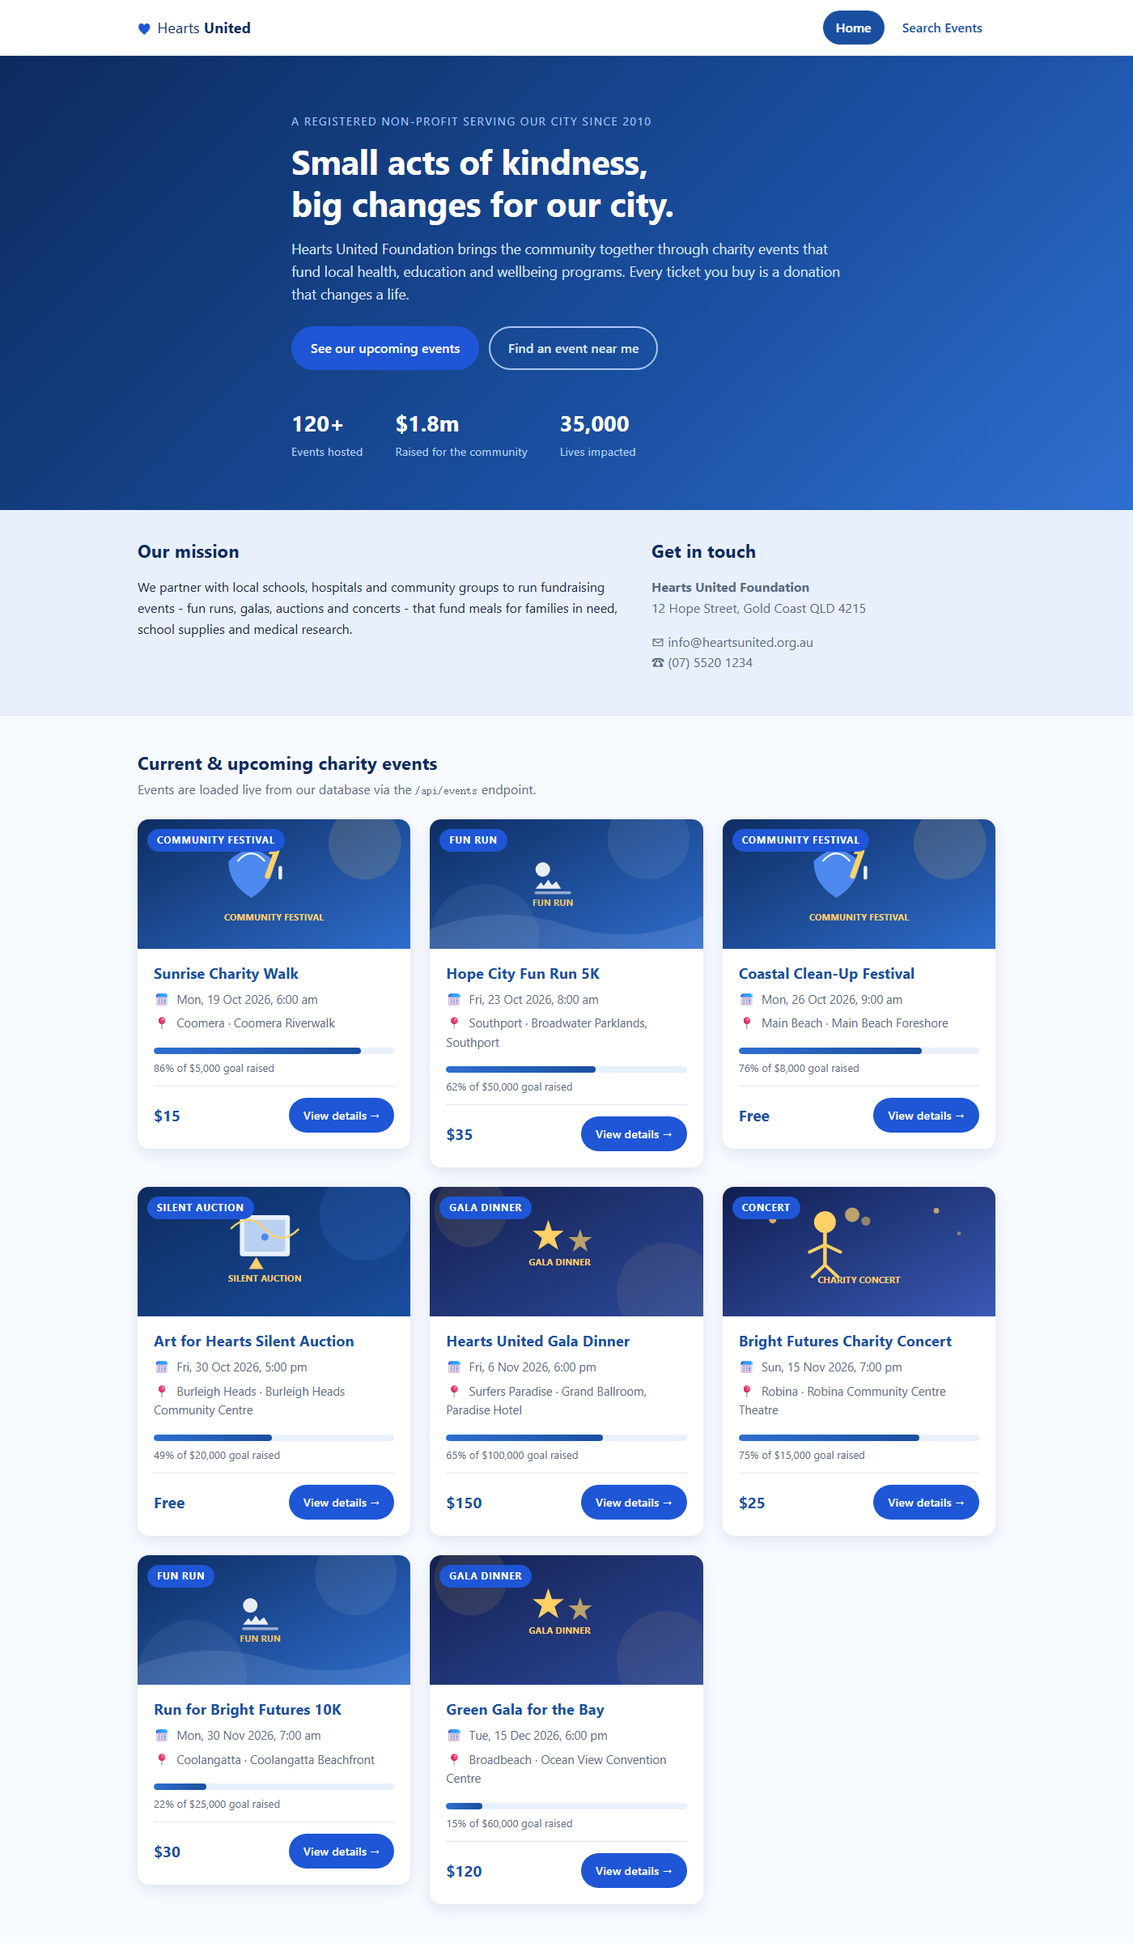
Figure 1: Client home page – hero, mission and the current/upcoming events loaded from GET /api/events.
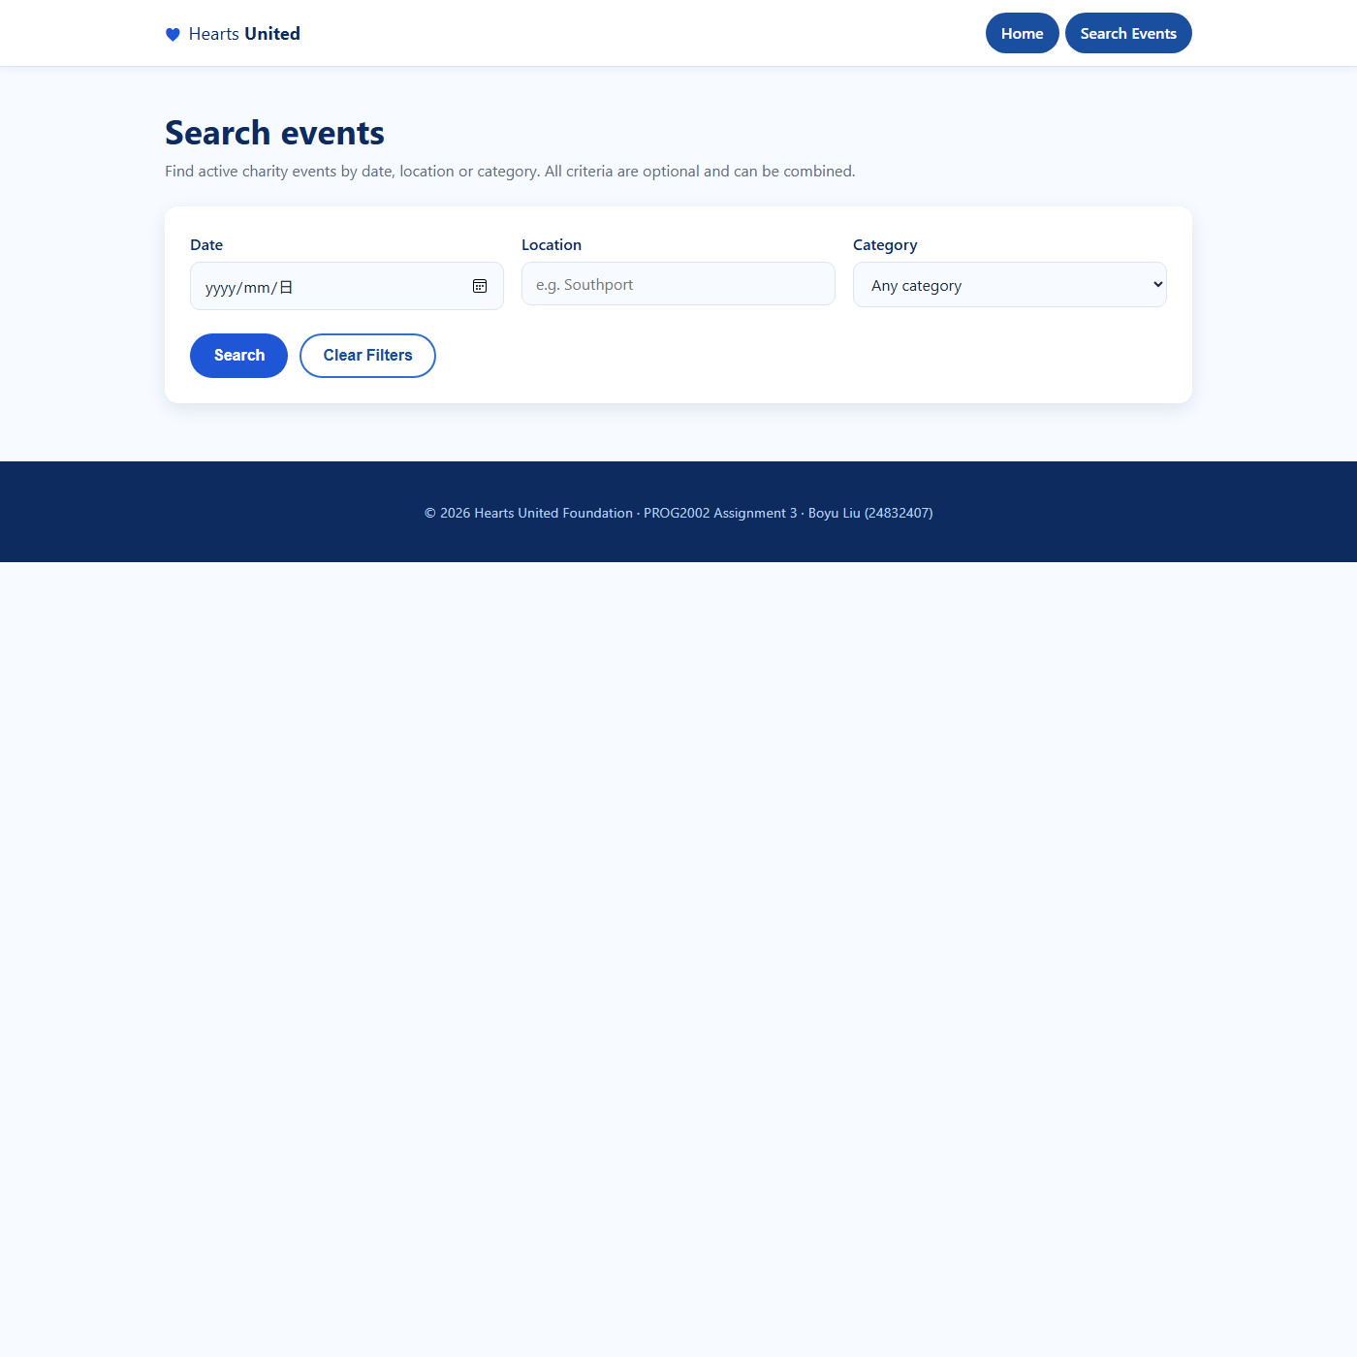
Figure 2: Client search page – date, location and category filters; the category dropdown is populated from GET /api/categories.
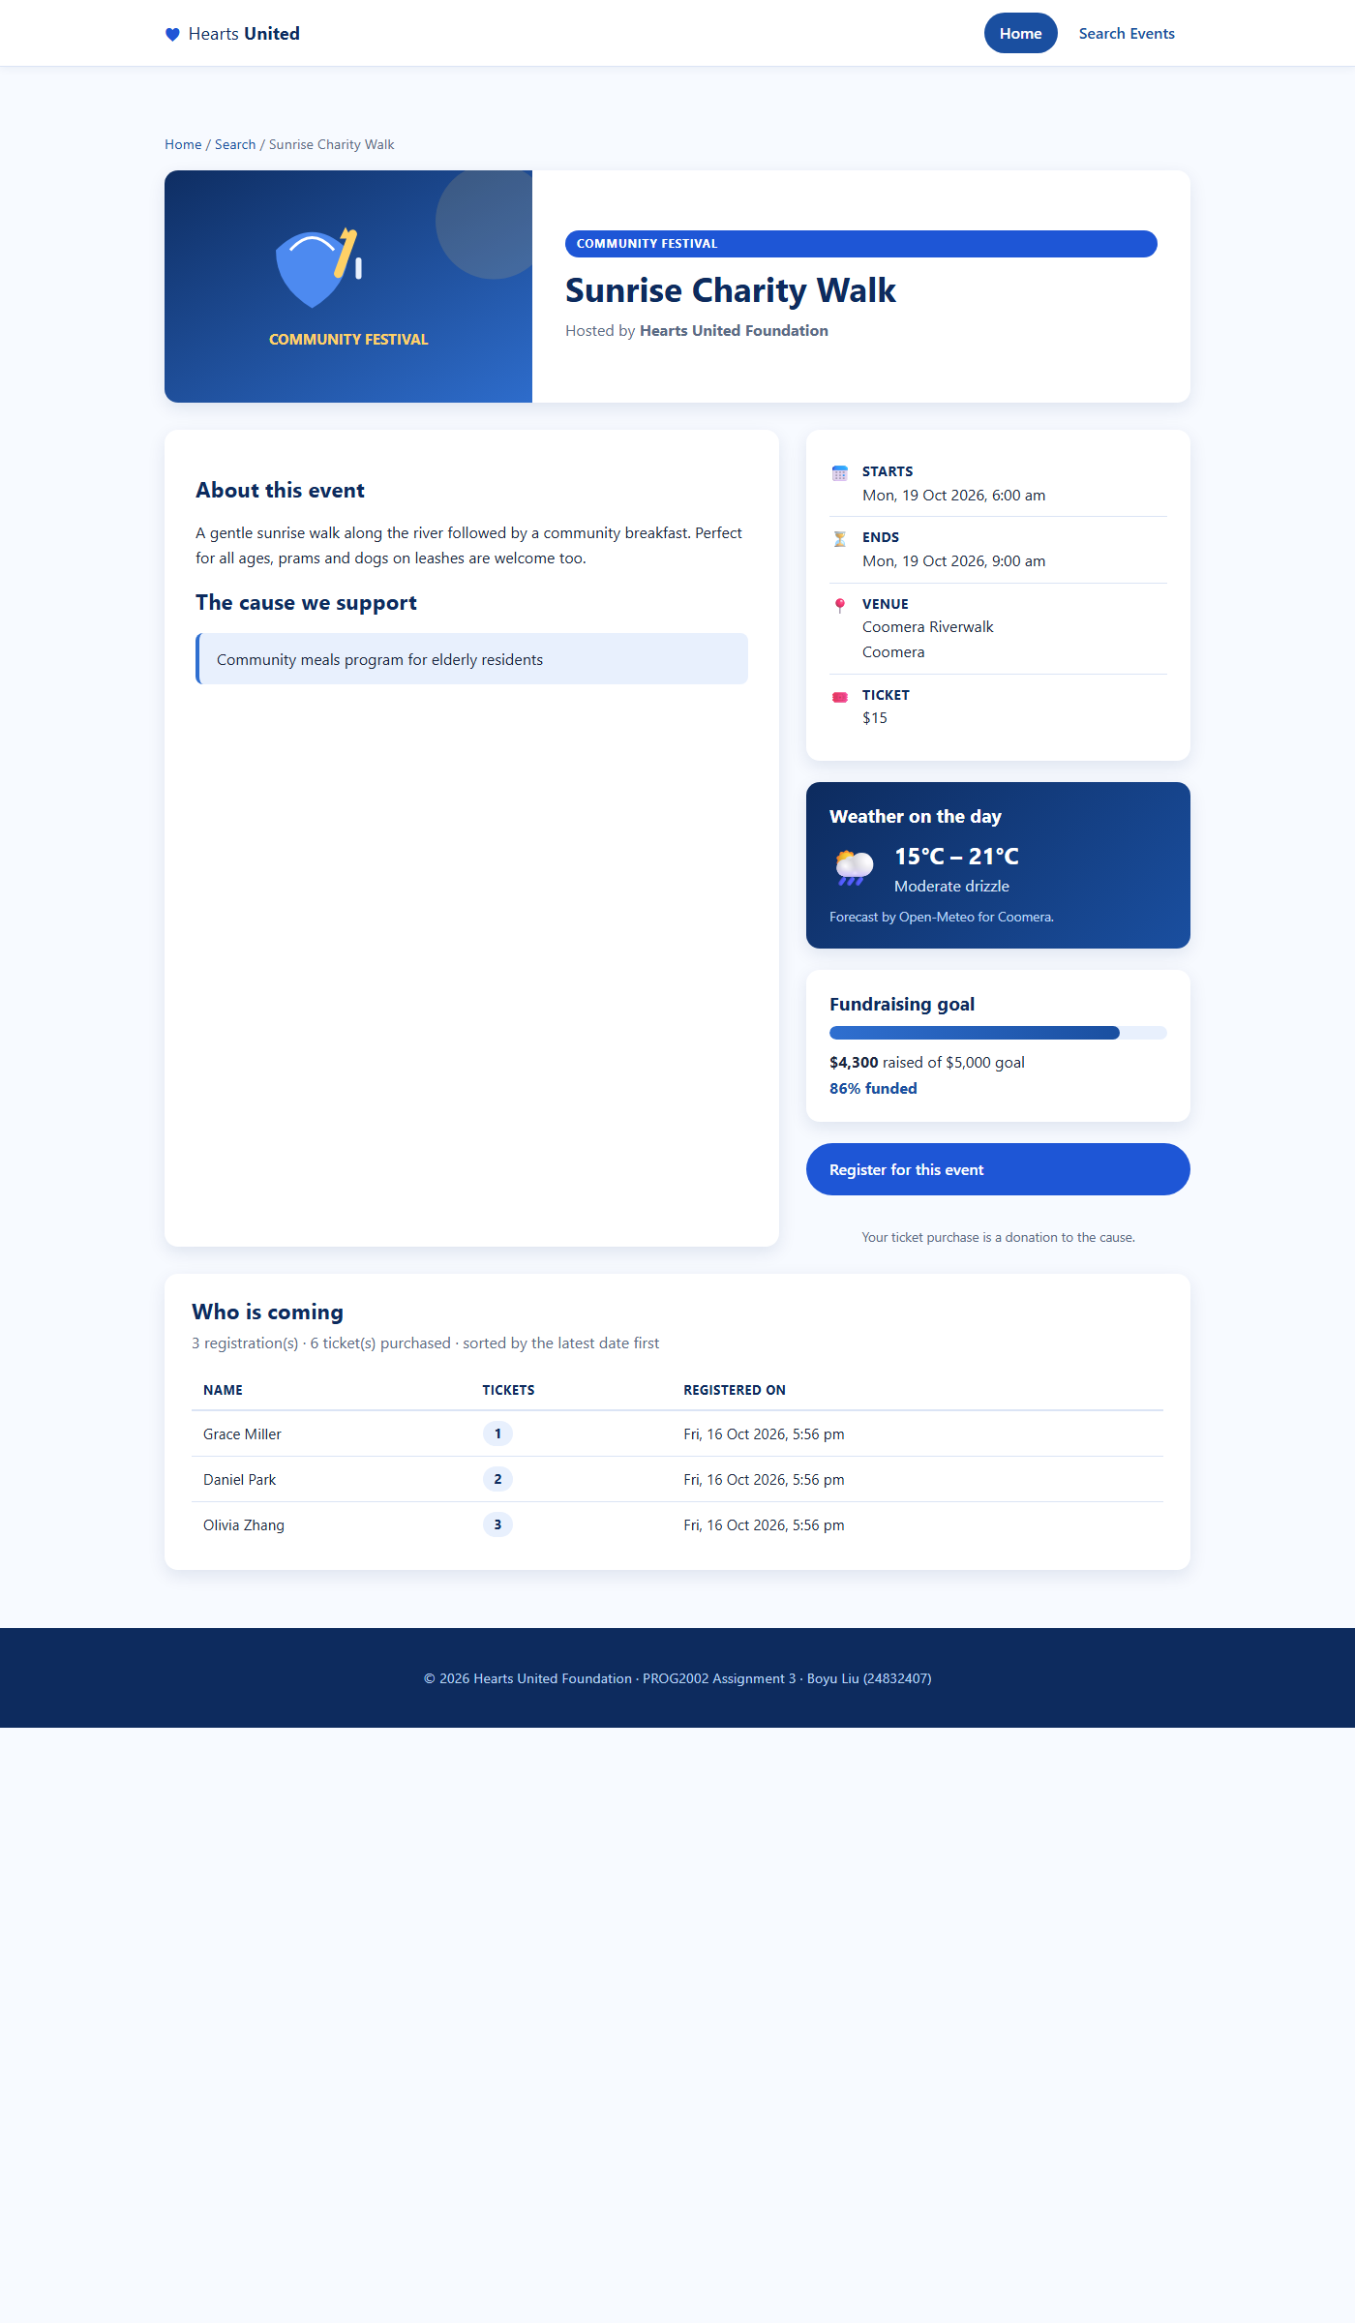
Figure 3: Event detail page – event data, the Open-Meteo weather forecast for the event day, the fundraising progress, the Register button and the registration list ("Who is coming") sorted by the latest date first.
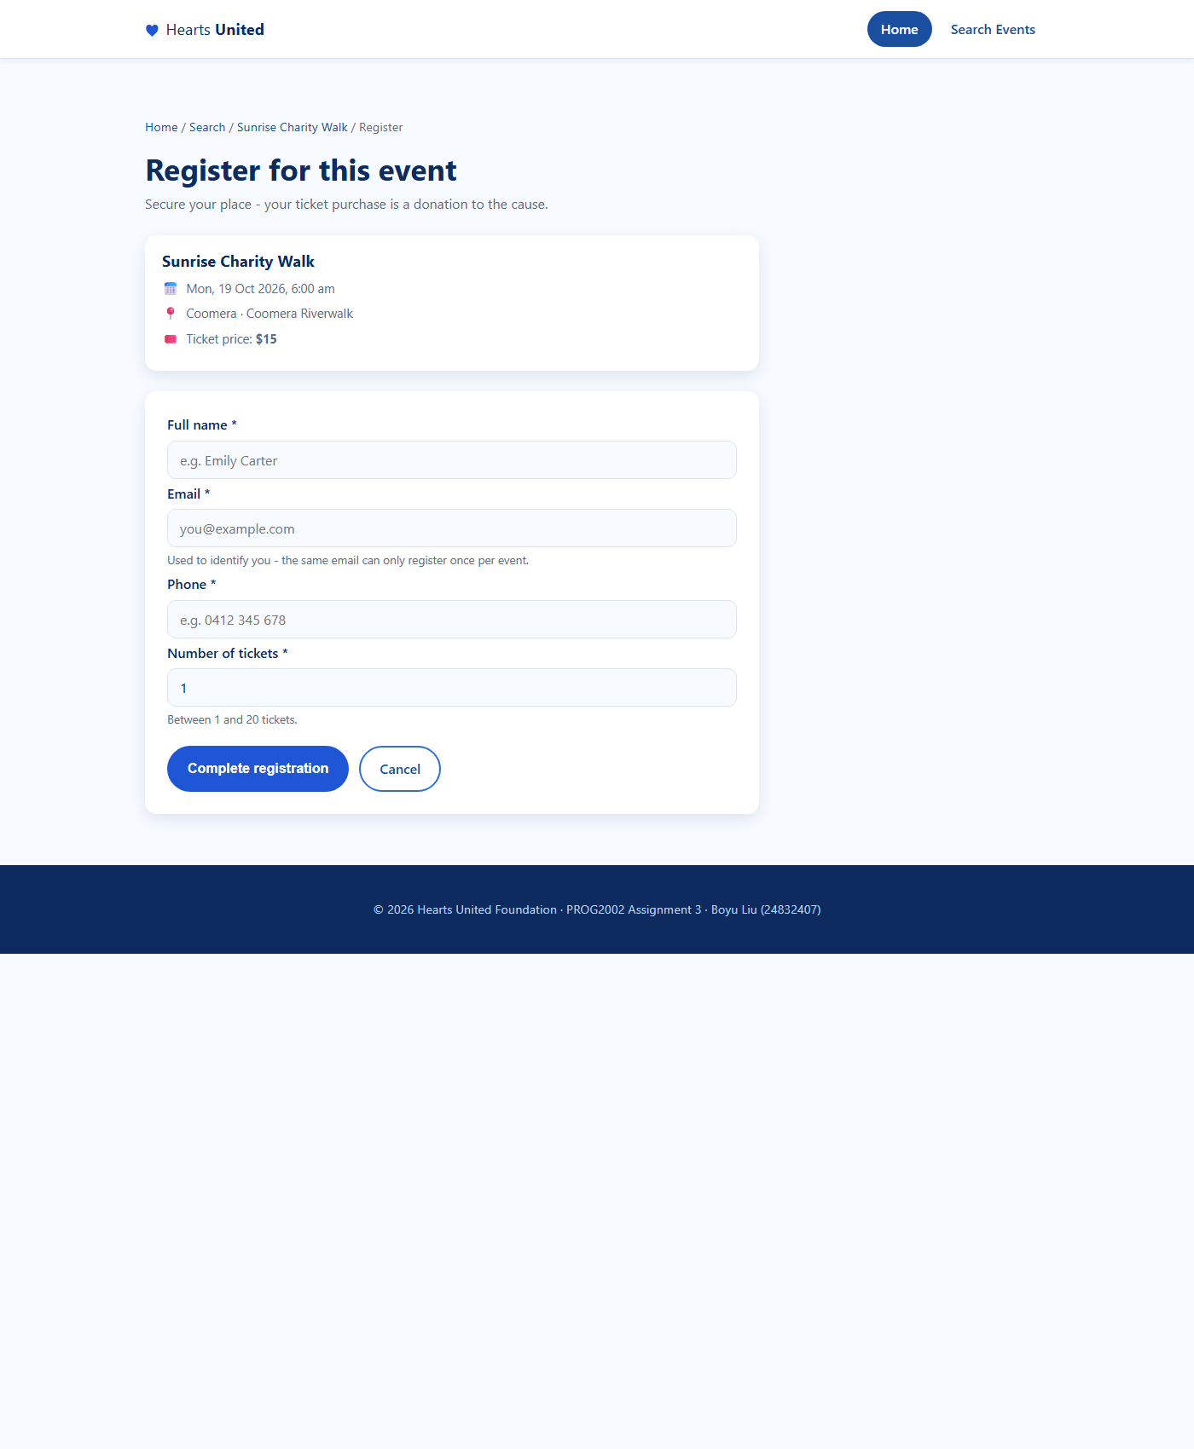
Figure 4: Registration page – the selected event is summarised on top and the form collects name, email, phone and the number of tickets.
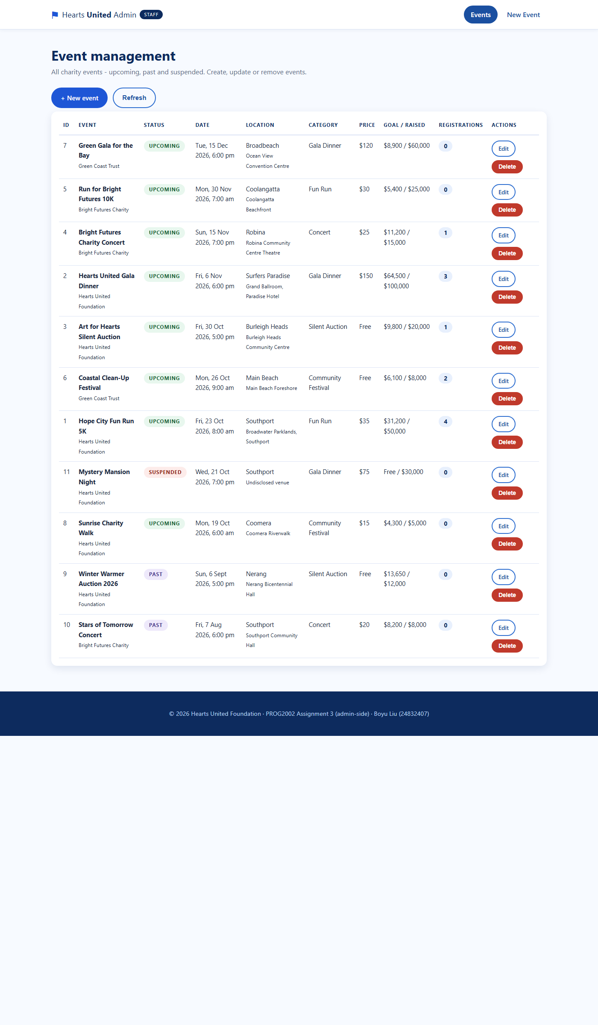
Figure 5: Admin list – every event regardless of status (Upcoming / Past / Suspended) with registration counts and Edit / Delete actions.
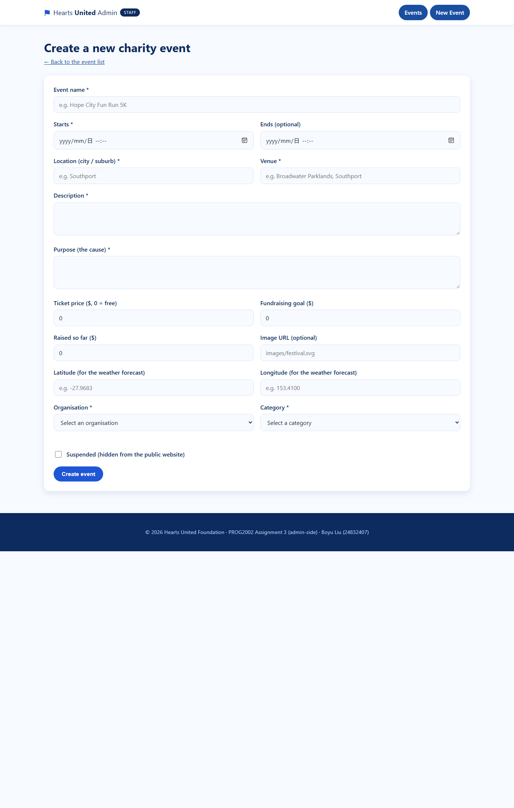
Figure 6: Admin "New event" form – validation ensures the essential fields are filled before POST /api/events is called.
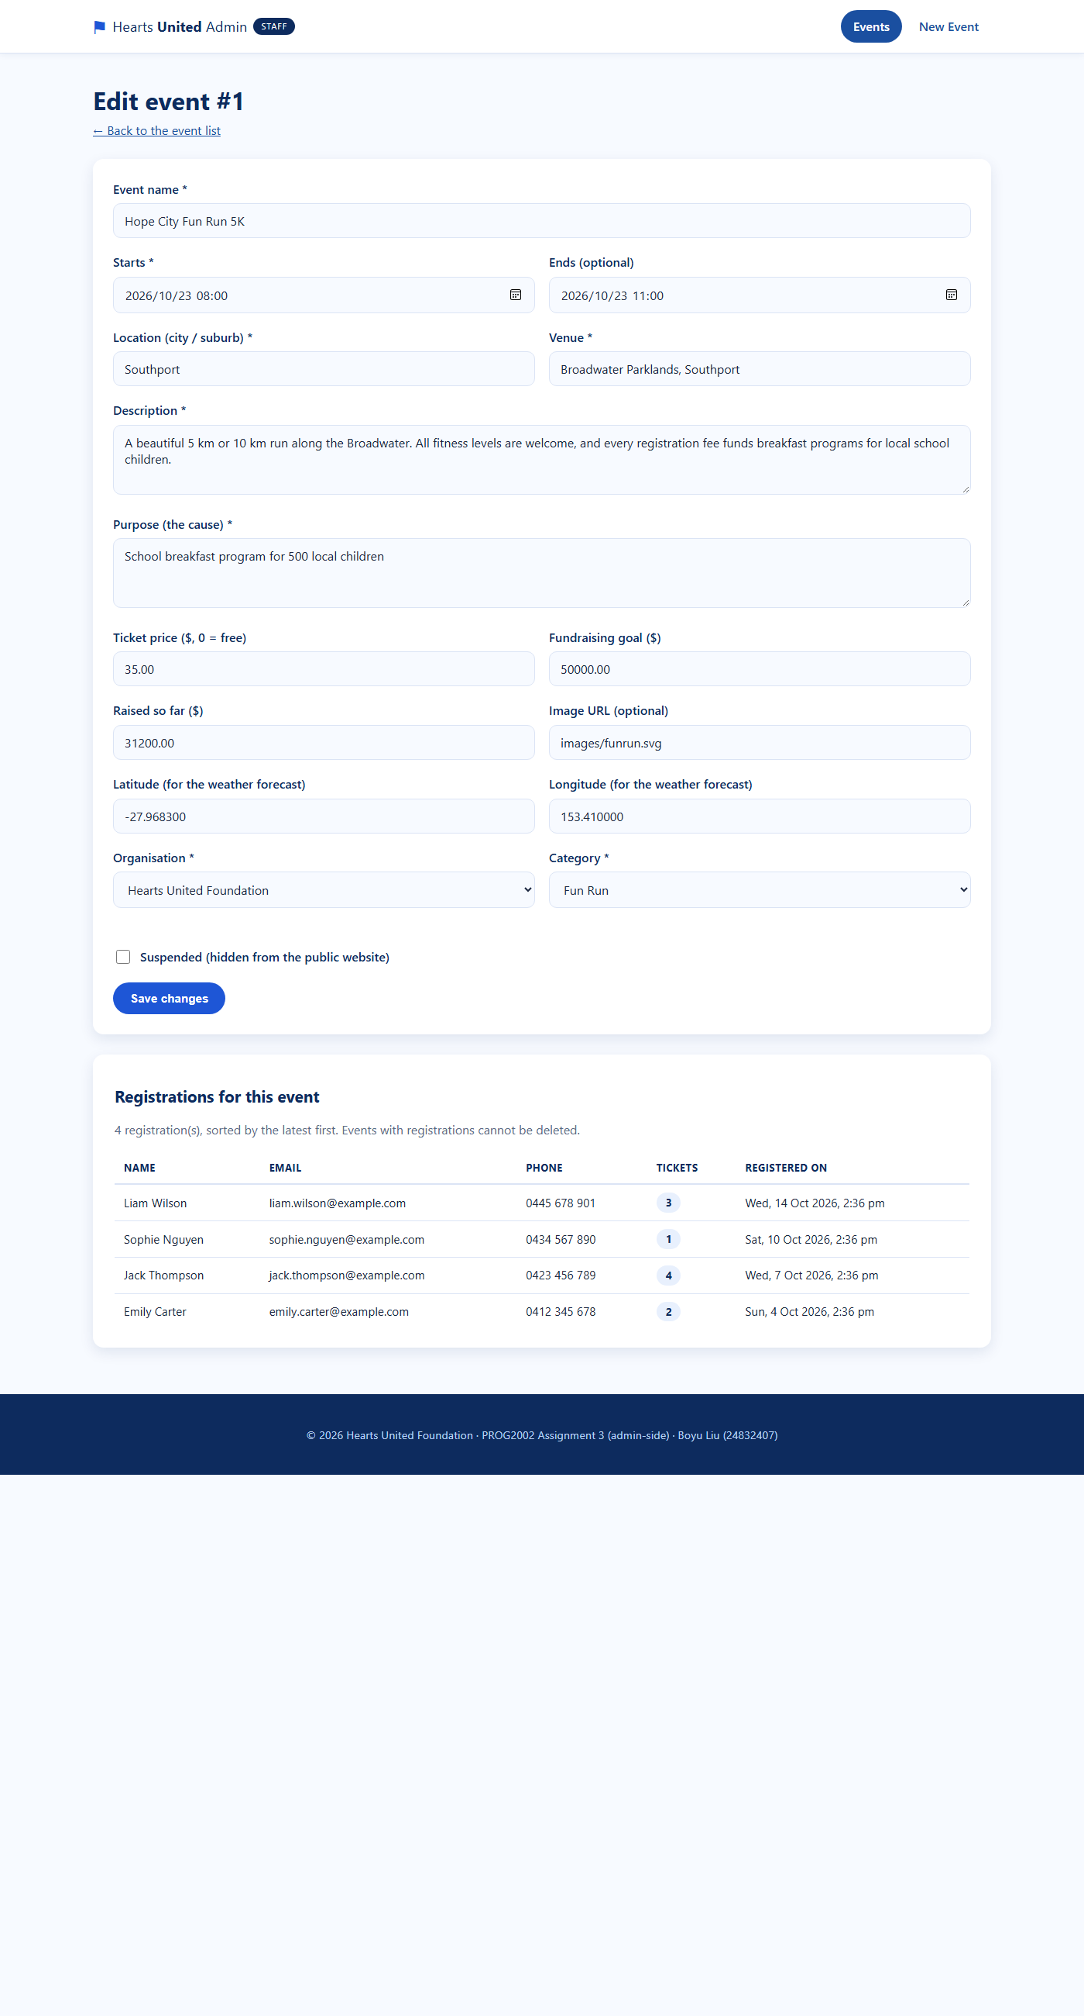
Figure 7: Admin "Edit event" form – pre-filled from GET /api/events/:id and showing the registrations recorded for this event.
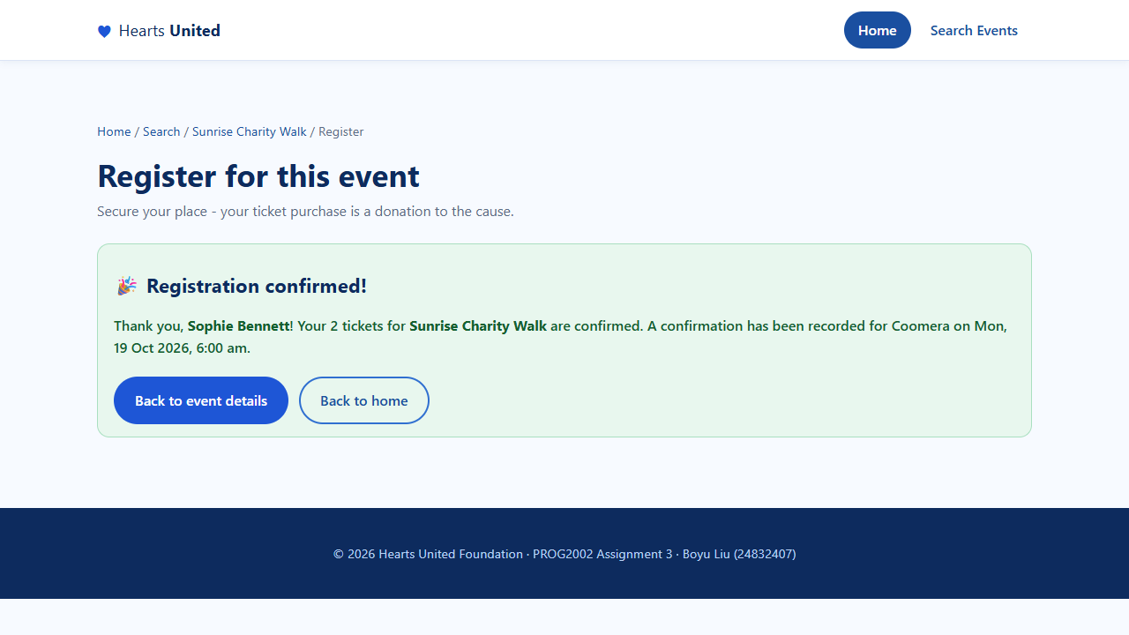
Figure 8: Registration confirmation — the API response confirms Sophie Bennett’s two tickets for the Sunrise Charity Walk, with navigation back to the event and to the home page.
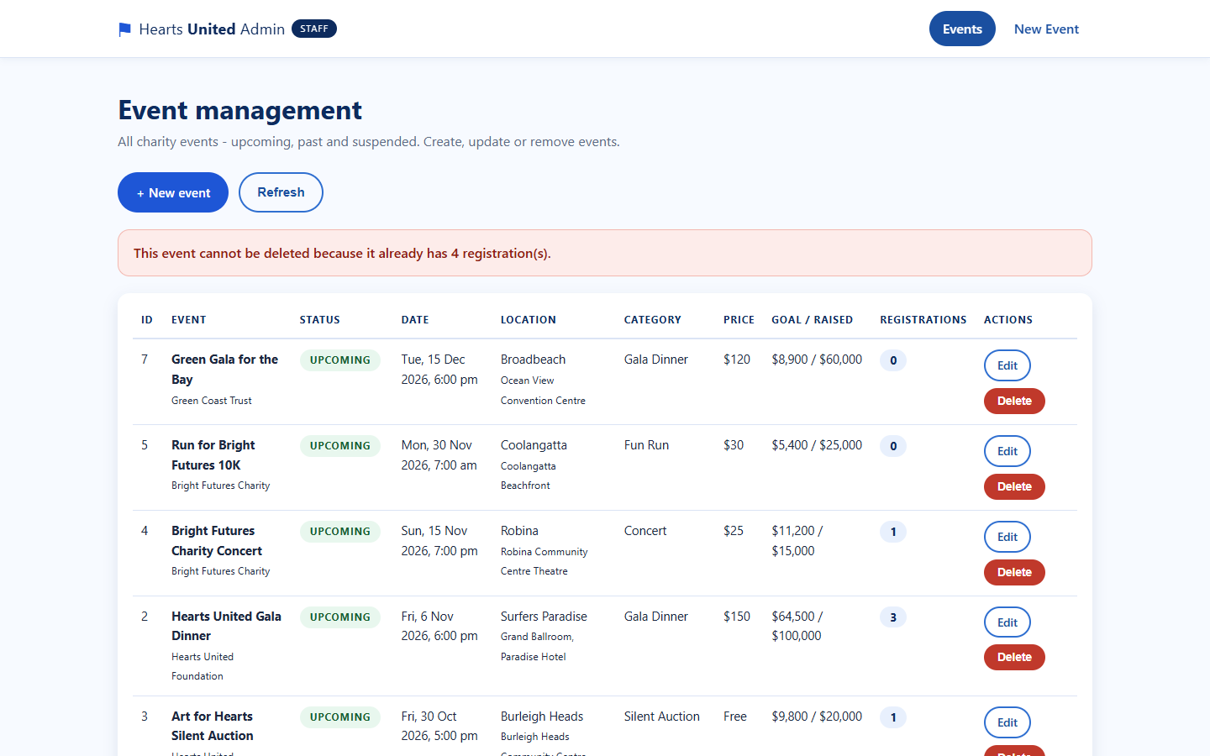
Figure 9: Blocked deletion — the dashboard calls DELETE /api/events/:id, the API answers 409 Conflict because the event still has registrations, and the reason is shown to the staff member.

Gen AI acknowledgement and Chat Log
I acknowledge that I have used GenAI tools to complete this assessment. I used CodeBuddy (an AI coding assistant) to assist with developing and debugging the application code, to help draft and structure this project report, and to check the grammar, clarity and formatting of the report, within the parameters outlined in the Assessment Brief and by the Unit Assessor.

Chat log
CodeBuddy (AI coding assistant) was used across the project. Typical uses were: explaining how the Angular router and HttpClient observables work together; debugging the MySQL import and the parameterised queries in server.js; designing the registrations table and its UNIQUE (event_id, email) constraint; fixing the admin edit page so that it displays the registrations returned by GET /api/events/:id; and checking the grammar, clarity and formatting of this report. Every suggestion was read, tested against the running application and adjusted before being kept.

